**Advanced Financial Management**

**Unit -2**

**Capital Structure Theories**

The Net Income Approach, The Net Operating Income Approach, Traditional Approach and MM Hypothesis–Problems on all the approaches.

**Net Income Approach:**

The Net Income approach was developed by David Durand (1959). As per Net Income Approach, there is a relationship between capital structure and value of the firm and therefore firm can affect its value by increasing or decreasing the debt proportion in the overall financing mix.

This approach shows that capital structure has relevance in determining the value of firm. Therefore, the value of a Levered firm (a firm which uses debt capital) will always be higher than the value of an Unlevered firm (i.e. an all equity firm). Further, the higher the amount of debt capital in the capital structure, the greater will be the firm’s value.

**The Net Income Approach makes the following main assumptions:**

1. The total capital requirement of the company is given and remains constant.

2. Cost of debt (Kd) is less than the cost of equity (Ke).

3. Both Kd and Ke remain constant and increase in financial leverage i.e. use of more and more debt financing in the capital structure does not affect the risk discernment of the investors.

4. There are no taxes and no transaction costs.

5. Firm has perpetual life

Given these assumptions it can be observed that as the proportion of debt capital increases in the total capital of a firm, its overall cost of capital declines continuously. This happens because cost of debt is lower than the cost of equity and irrespective of the degree of financial leverage, these two cost remain constant. Hence as the proportion of debt capital rises, cheaper debt replaces expensive equity capital and the overall cost of capital declines, resulting in increase in firm’s value.

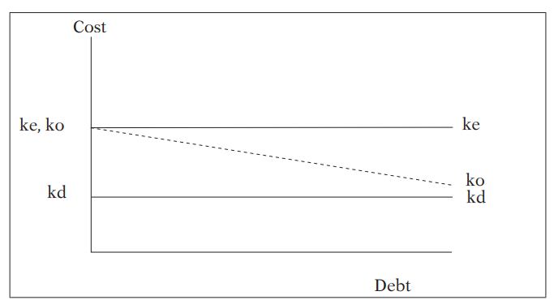

As per NI Approach:

* + Kdand Ke will remain constant.
  + Ko will decrease with the help of use of Debt.
  + MV of Equity and Firm will increase with the help of use of Debt.

**Net Operating Income Approach (NOI)**

According to this approach, capital structure decisions of the firm are irrelevant. Any change in the leverage will not lead to any change in the total value of the firm and the market price of shares, as the overall cost of capital is independent of the degree of leverage.

As per NOI Approach:

* + Kd,Ko and MV of Firm will remain constant in case of without tax structure.
  + Kdwill remain constant in case of with tax structure, with the increase in Debt, MV of firm will increase and Kowill decrease

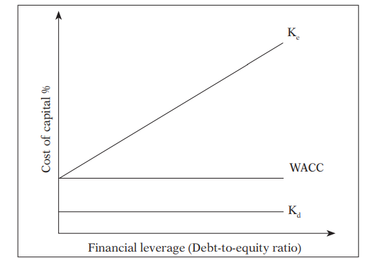

Value of Firms as per NOI Approach:

Step 1: Calculate Value of Unlevered Firm:

Value of Unlevered Firm (VU) = 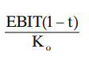

Step 2: Calculate Value of Levered Firm:

Value of Levered Firm (VL) = VU + DT

**Modiglani-Miller Approach (MM)**

The NOI approach is definitional or conceptual and lacks behavioral significance. However, Modigliani-Miller approach provides behavioural justification for constant overall cost of capital and therefore, total value of the firm.

Assumptions of MM Approach

* + Capital markets are perfect
  + All information is freely available
  + There are no transaction costs
  + All investors are rational
  + Firms can be grouped into ‘Equivalent risk classes’
  + Non-existence of corporate taxes

**Traditional Approach**

This approach favours that as a result of financial leverage up to some point, cost of capital comes down and value of firm increases. However, beyond that point, reverse trends emerge.

As per Traditional Approach:

* + Kd,Ke, Ko and MV of Equity and MV of Firm are variable
  + Company has to select capital structure with lowest Ko or highest MV of Firm

